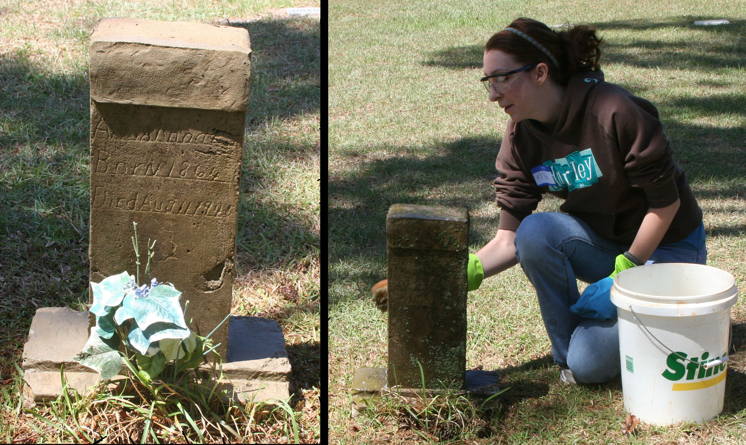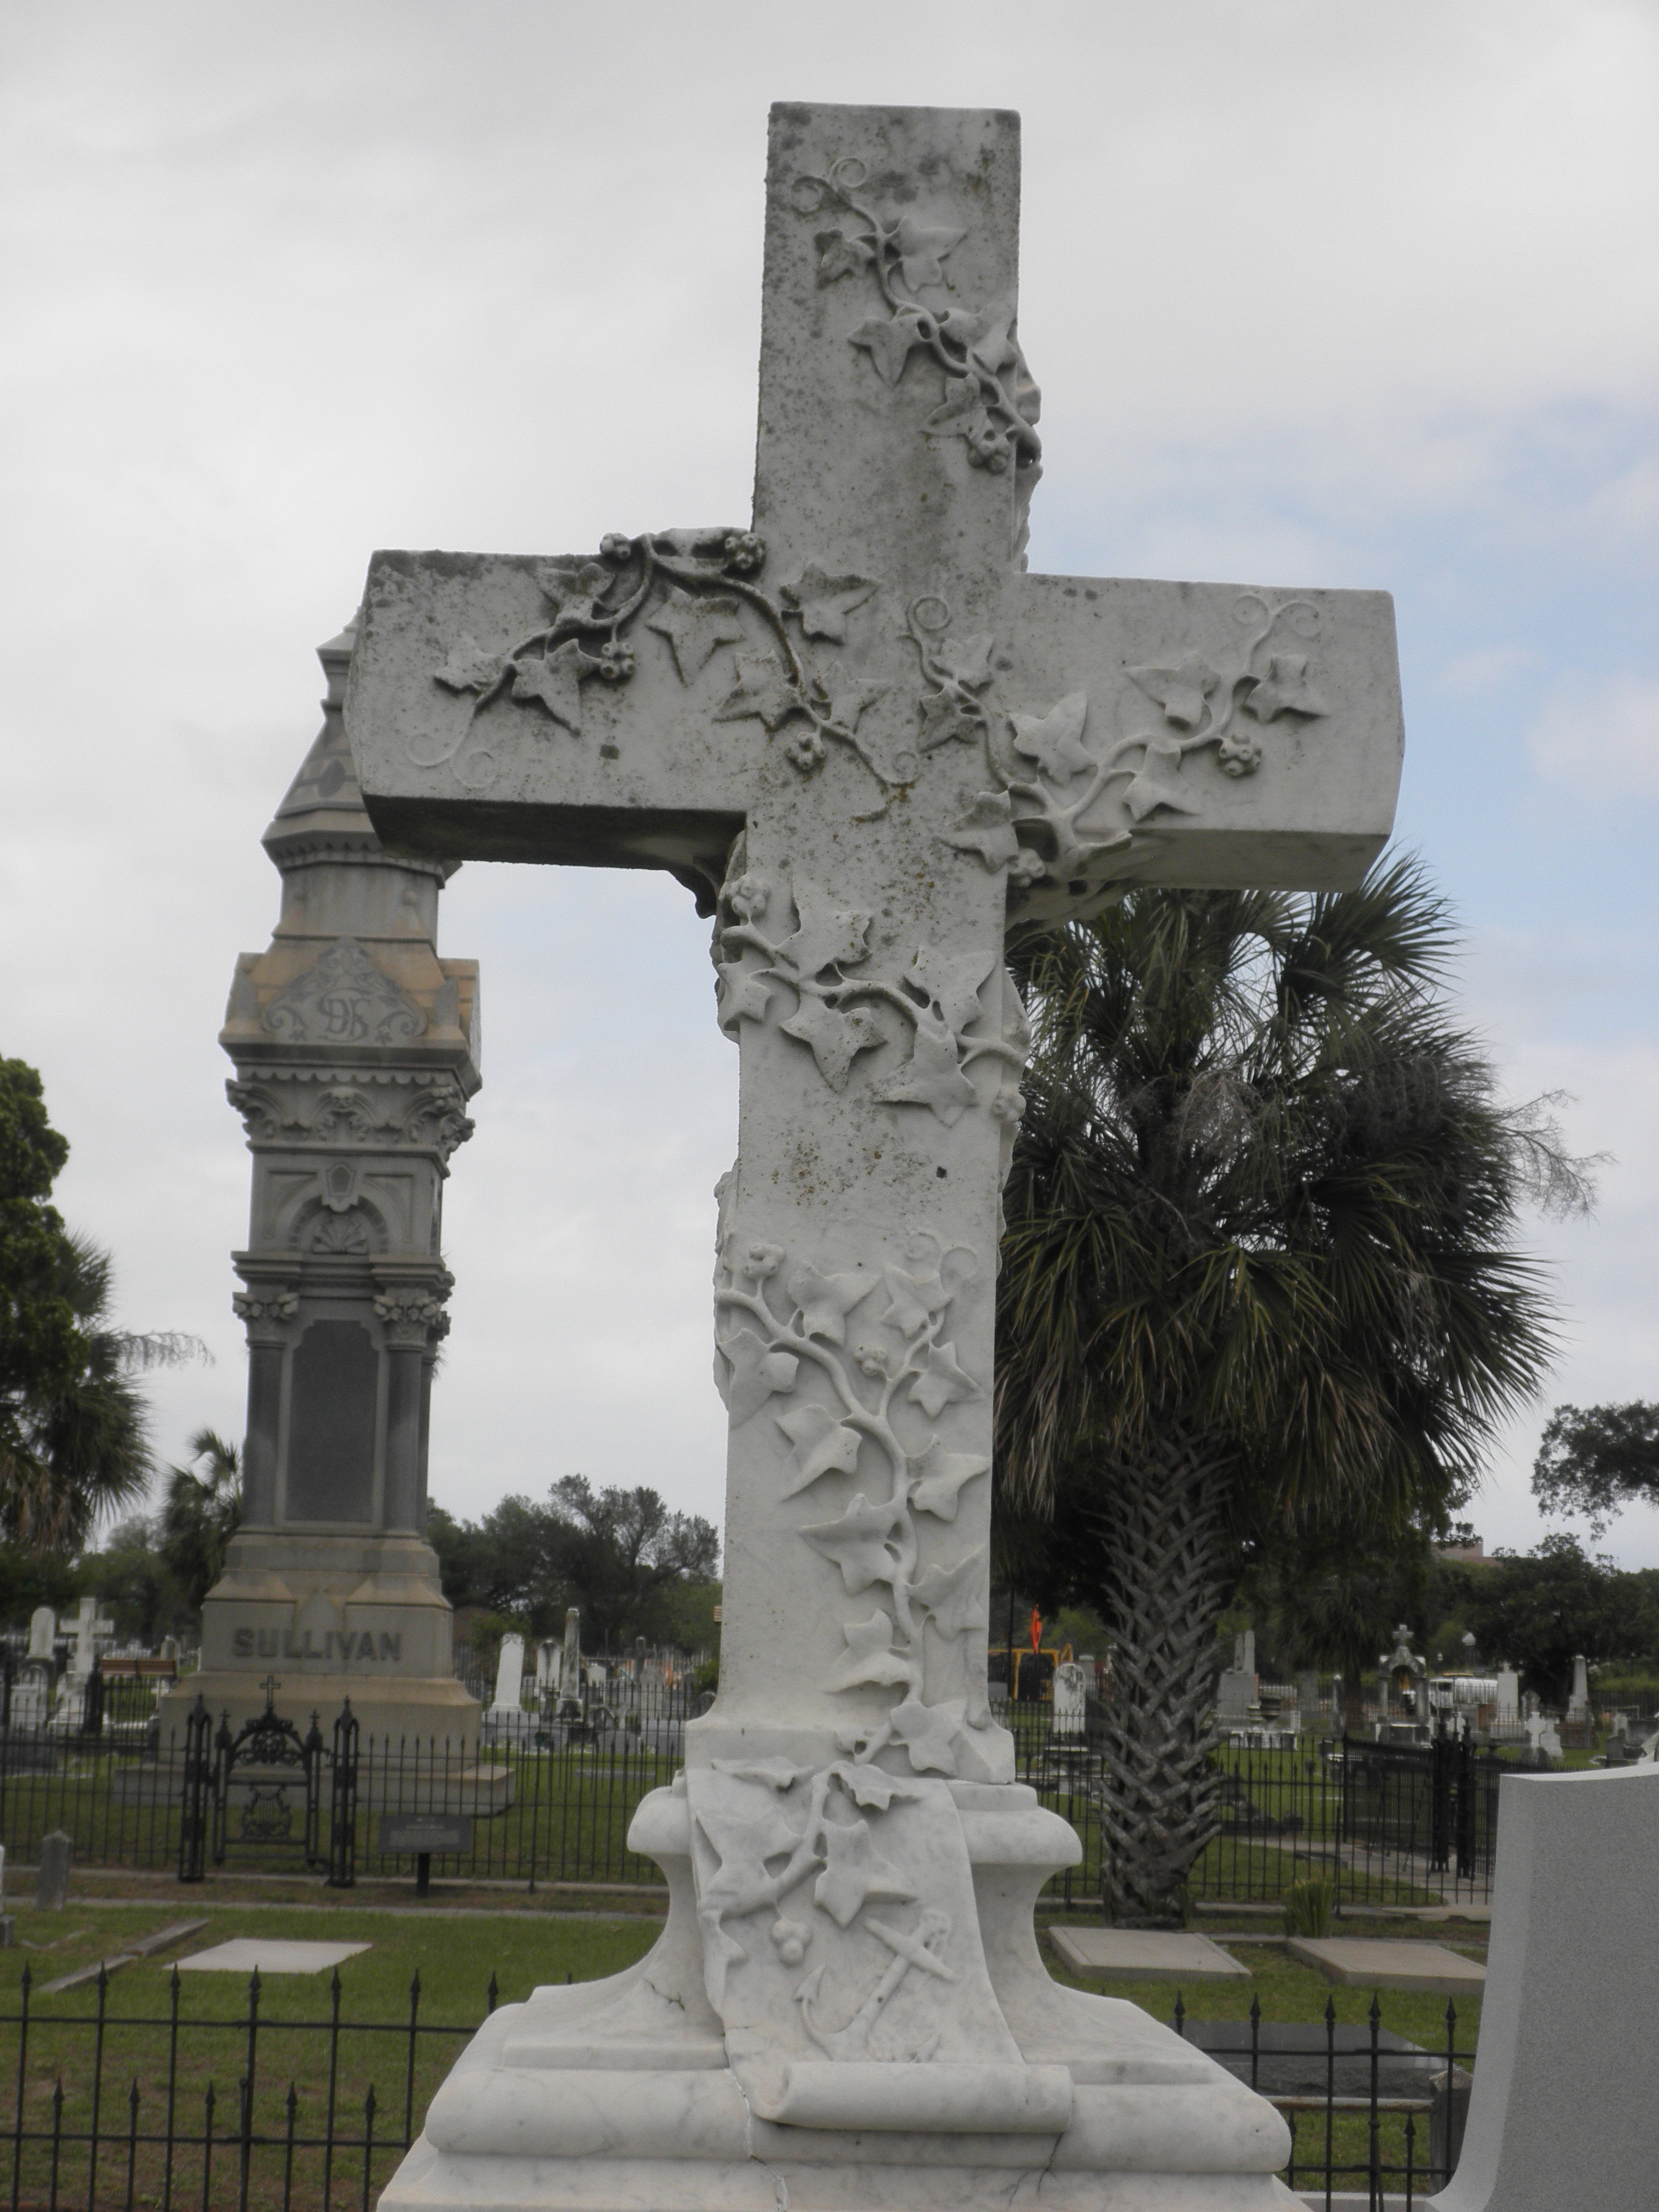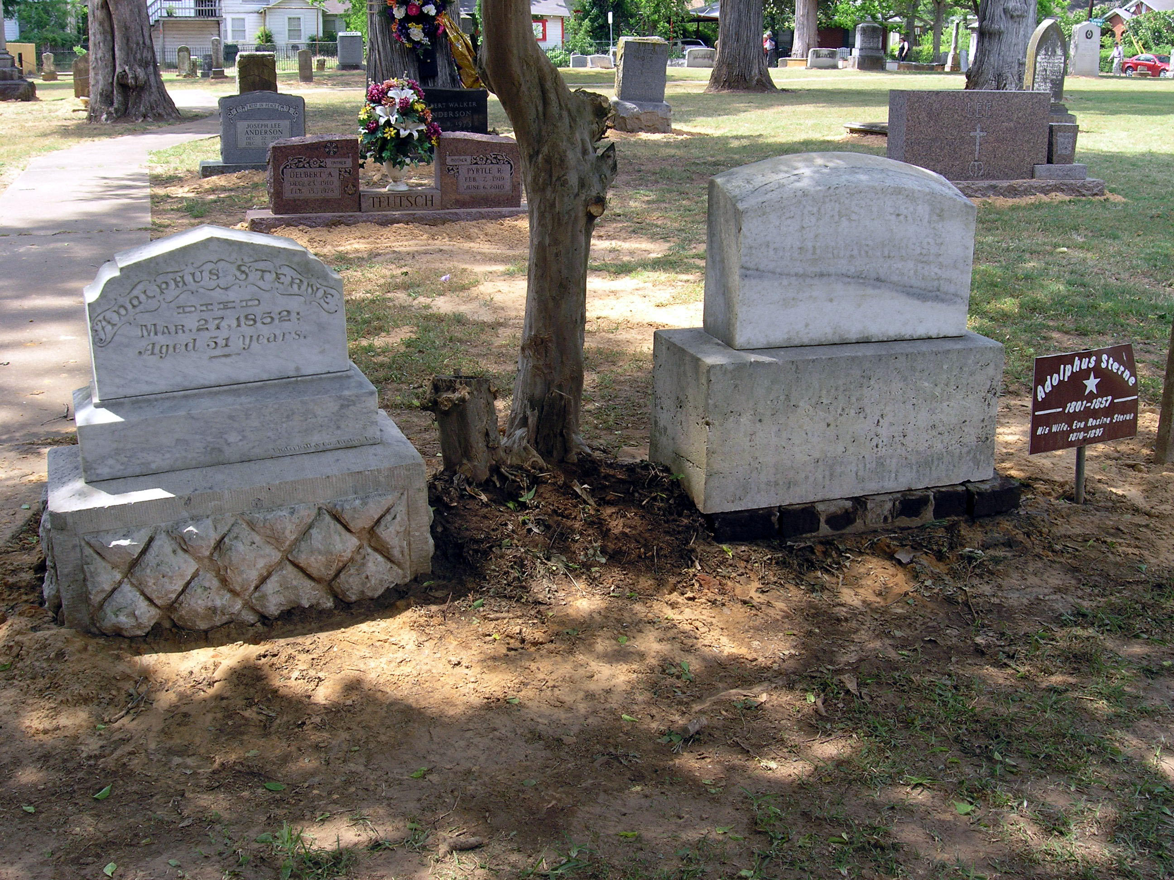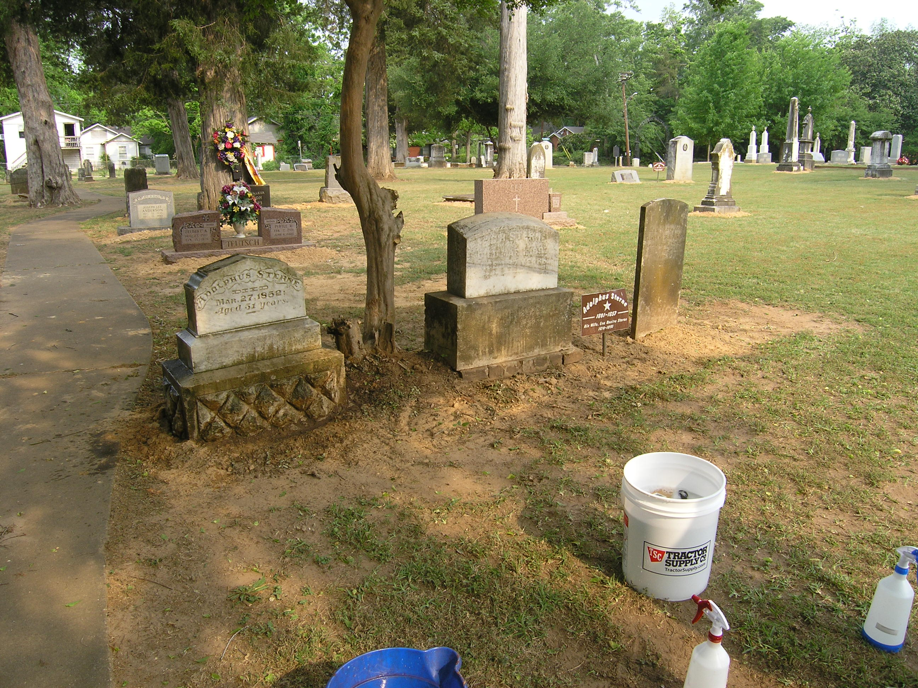

If you have any questions, family photos or records that you would like to share, or would like to arrange for me to clean your family’s headstones (for a small fee), please feel free to contact me at:

misty.hurley@ymail.com

🙞 🙜

My name is Misty Hurley and I am a Graduate Student in Public History at Stephen F. Austin State University. As part of my thesis I will be working on cemetery preservation as well as creating an interactive guide connecting the cemeteries of Nacogdoches with historic houses, museums, artifacts, and archival records.

## Misty Hurley

* The National Center for Preservation Technology and Training (NCPTT) of Natchitoches:

<http://ncptt.nps.gov/category/training/cemetery-monument-conservation-materials-research/>

* Texas Historical Commission:

<http://www.thc.state.tx.us/publications/guidelines/Preservecem.pdf>

* Chicora Foundation, Inc.:

<http://www.chicora.org/conservation.html>

For more suggestions and guidelines about cemetery cleaning and preservation, please visit the following websites:

Saturday,

May 12, 2012

Old North Church Cemetery

🙞 🙜

Cemetery Cleaning Workshop

Items Needed for Cemetery Cleaning

* Lots of Water
* Buckets
* Spray bottles
* Soft, plastic bristled brushes
* A gentle cleaner, such as Orvus
* Protective Gear – plastic gloves, glasses
* A Biocide (optional) – D-2 made by Cathedral Stone, Enviro Clean Bio Wash made by Prosoco

🙞 🙜

DON’T

* Don’t do anything that will remove or damage the surface of the stone, such as power washing or using wire brushes
* Don’t use bleach, chlorine, comet or other household cleaners. These products can damage the fragile composition of the stone, dissolve the stone surface, and leave deposits that further deteriorate the stone.
* Don’t use harsh mechanical methods to clean the stone such as sand blasting or power tools

DO

* Do no harm
* Check for damage or weaknesses that may mean the stone is too fragile to clean
* Select the gentlest cleaning method to accomplish the task, this means soft brushes and a gentle soap such as Orvus Paste
* Take safety precautions such as wearing gloves and safety glasses

Cemetery Cleaning Do’s and Don’ts

After

Before