CAEP Accountability Measure 3
Candidate Competency at Program Completion

Assessment Method:
Technology Proficiency Self-Assessment for 21st Century Learning (TPSA C21) (R3.3)

The EPP curriculum is aligned with ISTE and Texas Technology Standards. As a result, courses include assignments requiring the use of technology which are used to assess candidate competency. Although edTPA and the Texas Teacher Evaluation and Support System observation tool do not measure technology competencies per se, the expectation is that the technology tools learned in the EPP coursework are used to plan instruction, engage students, and assess student learning. In 2020-21 implementation of the Technology Proficiency Self-Assessment for 21st Century Learning (TPSA C21) began. The TPSA C21 measures educator self-efficacy regarding skills for integrating technology into classroom teaching and learning. The C21 version of the TPSA includes mobile technology and has been shown to remain a reliable and valid instrument to support preservice educators for planning professional development related to technology integration (Christensen & Knezek, 2017). The instrument includes six subscales: Teaching with Emerging Technologies, Teach with Technology, Integrated Applications, Emerging Tools, WWW, and Email. The following scale is used for all items: 1 Strongly Disagree, 2 Disagree, 3 Undecided, 4 Agree, 5 Strongly Agree.

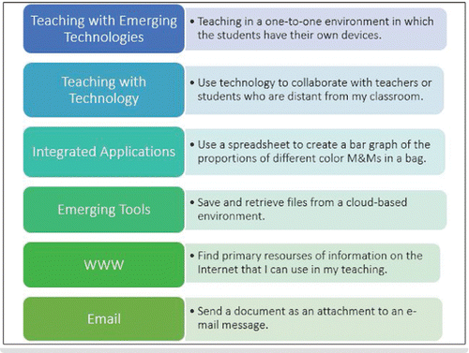

Citation: Rhonda Christensen & Gerald Knezek (2017) Validating the Technology Proficiency Self-Assessment Questionnaire for 21st Century Learning (TPSA C-21), Journal of Digital Learning in Teacher Education, 33:1, 20-31, DOI: 10.1080/21532974.2016.1242391)

Analysis and Interpretation of Results:
The instrument includes six subscales: Emerging Technology Skills, Teaching with Emerging Technologies, Teaching with Technology, Integrated Applications, WWW, and Email.

Fall 2023 and Spring 2024 Cycles of Data on Clinical Teachers at Program Completion

Results for all initial certifications in 2024-25 reveal mean scores at program completion across all domains was 3.29-4.44. The highest mean was Teaching with Technology while the lowest mean was Use of Integrated Apps. Review of results disaggregated by gender and race with groups that included at least 10 clinical teachers revealed Use of Integrated Apps was most often the lowest mean across all races. Disaggregation of data by certification pathway and gender and ethnicity revealed similar patterns. The EPP will continue to collect and monitor patterns in these data and determine its usefulness in making data informed decisions to support continuous improvement.

See data tables on the website at the link titled:
CAEP Measure 3 Technology Proficiency Results

