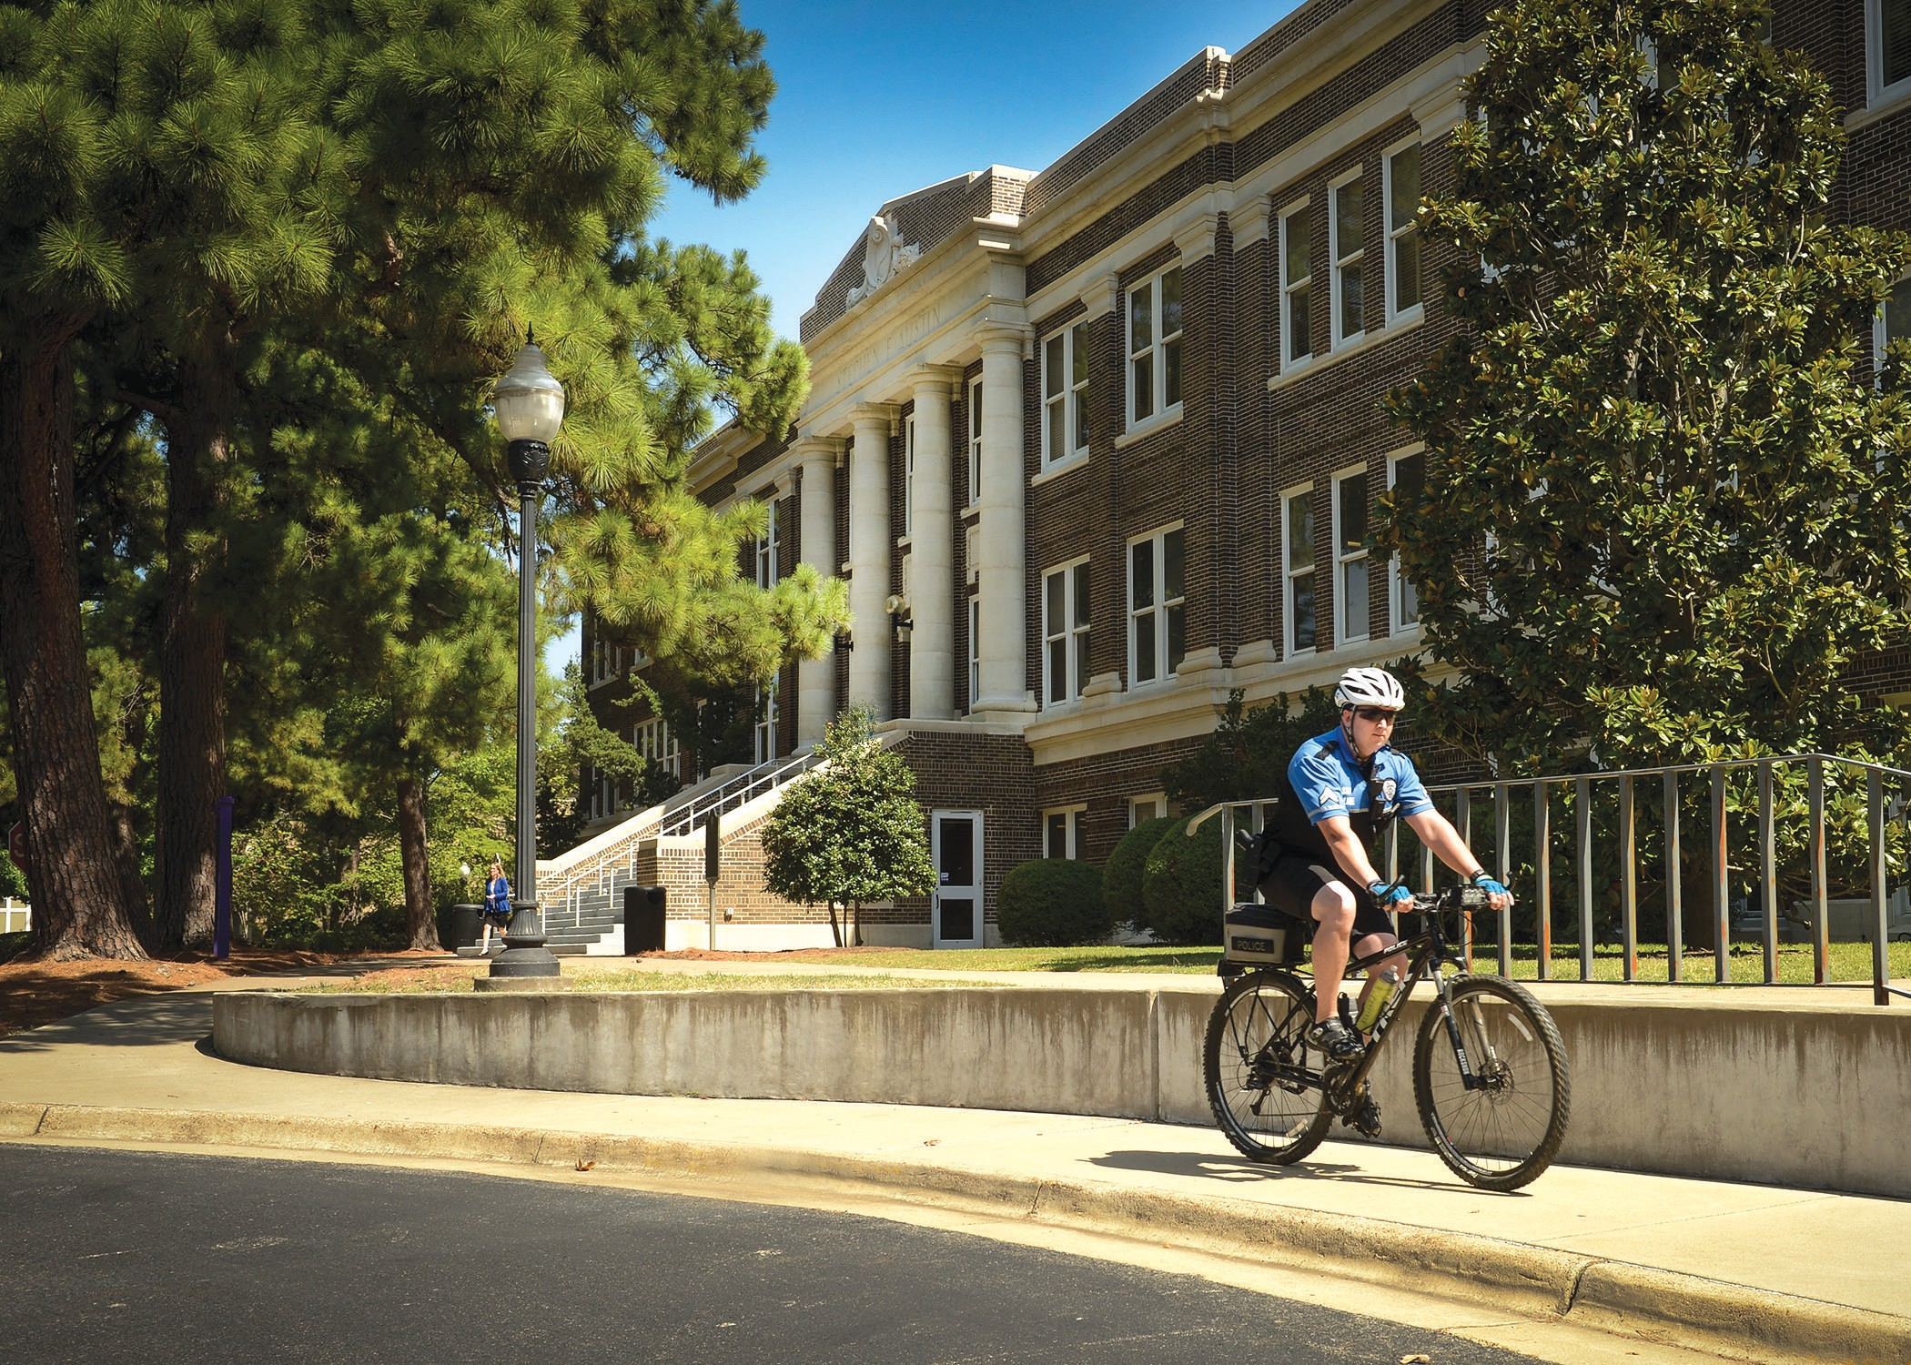

|  |
| --- |
| *October 2022* |

|  |
| --- |
| Building Captain  Emergency Planning Handbook Template |

A preparedness planning guide for Building Captains

|  |
| --- |
| Sfasu.edu/upd/emergency-management |

This page intentionally left blank

|  |  |
| --- | --- |
| Address:  *[Building/Facility/Complex Name]*  *[Address]* | |
| Occupants (s):  A contact list can be found in section 7.2  Assembly Areas:  Primary*: [Identify location]*  Secondary: *[Identify location]*  Shelter Locations:  Primary*: [Identify location]*  Secondary: *[Identify location]* | Emergency Contacts:  A full contact list can be found in section 7.2  *[List names and office/cell phone numbers of persons that need to be contacted in the case of an emergency such as Deans, Department Leads, Key personnel ect…] Should be consistent with Business Continuity Plan (BCP)* |
| AED Location(s): *[Identify location(s)]**AED’s should be visually checked monthly…report any issues to the Emergency Management Office* |
| Fire Extinguisher Location(s):  *[Identify location(s)]**Extinguishers should be visually checked montly...report any issues to the Emergency Management Office* |
|  |

**For additional information regarding creating emergency action plans, contact:**

**SFA Emergency Management Office @ ext. 1667**

**For additional information regarding overall campus safety and security, visit:**

**https://www.sfasu.edu/upd**

Table of Contents

1: Introduction 5

1.1 Purpose 5

1.2 Responsibilities 5

2: Quick References 6

2.1 Building Map/Facility Floor Plans 6

3: Communications 7

3.1 Reporting Emergencies 7

3.2 Campus Emergency Notification 7

3.3 Intercommunication 8

4: Emergency Actions 8

5: Preparedness 8

6: Types of Emergencies 9

7: Attachments/Appendices 13

7.1 Attachment 1: Emergency Items and Equipment 13

7.2 Attachment 2: Contact Lists 14

## 1: Introduction

* 1. Purpose

This Handbook is designed to provide your facility/department with guidance on how to prepare for and respond to a range of emergencies. You are welcome and encouraged to modify this handbook to address other topics or to remove ones that do not pertain to your building and or department.

* 1. Responsibilities

All faculty, staff, and students share the responsibility of emergency preparedness. You are encouraged to work with your building and department to familiarize yourselves with the actions outlined in this handbook. In addition, you should:

* Sign up for Jackalert RAVE Gaurdian Emergency Alerts;
* Have an up-to-date emergency kit for your department;
* Maintain a current list of emergency contact information;
* Procure and maintain necessary emergency supplies, equipment and items as necessary;

## 2: Quick References

### 2.1 Building Map/facility Floor Plans/Quick Reference Guide Supplement

*[Insert Building Map/facility Floor Plans Here with designated Assembly Areas and Shelter Locations]*

## 3: Communications

### 3.1 Reporting Emergencies

Report emergencies by calling 911. All 911 calls are answered by, the county’s emergency dispatch center; therefore, you should indicate to the dispatcher your exact location. This will help the dispatcher determine which service to dispatch. Additionally, you can contact the SFA UPD directly by calling 936-468-2608.

When reporting an emergency situation, provide the dispatcher with the following information:

* Your name
* The location of the emergency
* The nature of the emergency - a brief description
* Any additional information they request

Note: **Do not hang up.** Stay on the phone until the dispatcher advises it is okay to end the call.



### 3.2 Campus Emergency Notification

An SFA Emergency Alert will be used by the University to notify members of the campus community of an emergency which threatens life or safety on campus.

If you receive an SFA Emergency Alert:

* Immediately respond in accordance with directions provided via the alert, and/or use best judgment on how to respond based on your specific set of circumstances and location.
* Communicate by word-of-mouth to others who may have not yet received the alert.
* Updates will be posted to sfasu.edu/upd banner, so check back in regularly.
* Remain calm and make wise decisions relative to your personal safety.

3.3 Intercommunication

*Utilize this space to describe the communication methods that you will use in order to communicate any emergency between your departments, faculty & Staff. Should be in-line with your Department’s Business Continuity Plan (BCP). Telephone recall, pyramid recall list ect…..*

*Things to include*

* *Identify an emergency out of town contact.*
* *List and distribute important contact information*
* *Verify that all key personnel phone numbers are in the plan.*
* *Exits for all rooms, buildings in an emergency*
* *Have a assembly area to meet for accountability*
* *Closest area to seek refuge from a tornado*

## 4: Emergency Actions

### 4.1 Example (Evacuation)

* You can utilize Emergency Actions from the quick reference guide and add here if you like or simply reference the Emergency Quick Reference Guide when needed.

##### Building or Facility Assembly Areas

The assembly point(s)are located:

*[Insert locations here]*.

#### 4.1.1 Accountability

After evacuating, you should immediately account for everyone to ensure the whereabouts and wellbeing of each individual within your department/facility. This is important so you can share the status of any missing people with first responders, who will conduct searches. Also Identify those with functional needs that might require assistance.

**5: Preparedness**

Preparedness is the responsibility of every person within the facility/department. Emergencies typically occur without warning, so any one of us could be in a position to act in a moment’s notice.

Every member of the SFA community shares the responsibility of emergency preparedness. Signing up for SFA Emergency Alert is the best way to be notified of a campus emergency. Visit **sfasu.edu/upd/emergency-management/jack-alert** to learn how to sign up.

Visit the Emergency Management website (sfasu.edu/upd/emergency-management) to find guidelines and more information.

**6: Types of Emergencies**

* Common situations below, Edit as you see fit utilizing the quick reference guide to stay consistent

6.1 Medical Emergencies

*   
    
  *[Identify AED location(s) here, if applicable]*.

### 6.2 Tornado Warnings

Tornado Warnings will be issued when a funnel cloud or tornado has been spotted or RADAR has indicated a tornado threatening the area. In addition to the National Weather Service warning, the SFA Federal Signal/Normal Outdoor Warning Sirens will also be activated when a Tornado or funnel cloud has been spotted. In either case, you should to take cover immediately. In the event of a tornado warning, you should:

* Collect Emergency Equipment

Keep a cell phone with you in order to receive additional emergency information or to monitor the National Weather Service for updates. Keep a flashlight and a portable battery-operated radio in a common area, if possible.

* Take shelter

Immediately move to inner hallways, stairwells, underground tunnels, rest rooms, or other areas on the lowest level of the building which are directly supported and relatively free from exterior windows and glass. If you are outside during a tornado warning and do not have time to move inside for shelter, move to a ditch or other low spot below grade level where you can lie (flying debris causes most deaths and injuries during a tornado).

*[Note designated areas here]*

* Avoid Dangerous Areas

Always avoid the upper floors of a building and areas such as elevators, lobbies, gyms, atriums, auditoriums, any area with windows, or dining centers.

### 6.5 Fires

#### WHEN FIRE OR SMOKE IS DISCOVERED, RACE TO RESPOND

* **RESCUE OR REMOVE** anyone, including yourself, who is in immediate danger from the fire to the closest safe area. Simultaneously notify other building occupants to evacuate the area. Use the stairs. Do not use elevators.
* **ACTIVATE THE ALARM** the alarm by pulling the nearest fire alarm pull station, and call UPD **911**.
* **CONFINE OR CONTAIN** the fire by closing all doors and windows in and around the fire area to prevent the spread of smoke and fire. Shut off all appliances and other equipment if safe to do so.
* **EXTINGUISH** the fire with a portable fire extinguisher, if safe. Evacuate the area. Use fire extinguisher on small fires only, trash cans or smaller. After extinguishing a fire, back away and watch for re-ignition. Attend fire extinguisher training.

#### IF YOU CAN’T EVACUATE:

* Move to a safe location with fire-rated walls, doors and few interior openings.
* Use a phone to call UPD **911** for assistance.
* Place wet towels or other materials around or under doors to keep smoke out.
* Display a sign or signal in the window to alert others to your location.
* Heat and smoke rise, so stay as low as possible. Breathe shallowly through nose, and use clothing as a filter.
* If clothing catches fire: **STOP, DROP AND ROLL.**

6.5.1 Fire Extinguishers

Portable fire extinguishers should be readily available in your department **and should be visually check monthly.**

* To use a fire extinguisher, it is helpful to remember the acronym PASS. PASS means:

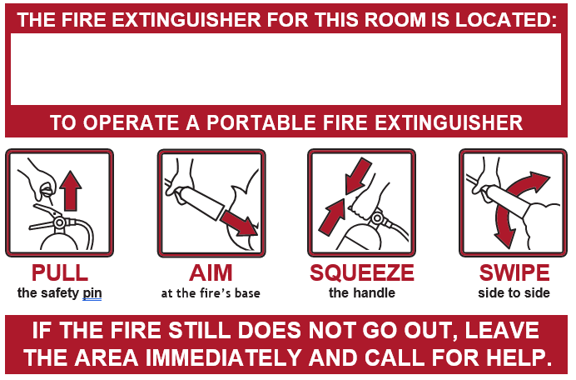

Fire Extinguisher(s) in are located: *[insert location(s) here]*

### 6.6 Other Emergencies

*[****Describe in this section*** *any other emergency procedures that you feel are pertinent to your department. Example, (laboratory procedures ect….]*

## 7: Attachments/Appendices

### 7.1 Attachment 1: Emergency Items and Equipment

All departments are encouraged to build a kit with items to sustain themselves for 72 hours in case of emergencies. List the location of this kit and other emergency supplies and items your department maintains or has access to: Not mandatory, just a suggestions and good practice.

|  |  |
| --- | --- |
| Emergency Supply or Item | Location(s) |
| Copy of this Plan |  |
| Contact List |  |
| Emergency Kit |  |
| First Aid Kit |  |
| Water |  |
| Battery operated radio |  |
| Flashlights (w/ extra batteries) |  |
| Automated External Defibrillator (AED) |  |
| Fire Extinguisher |  |
|  |  |
|  |  |
|  |  |
|  |  |
|  |  |

### 7.2 Attachment 2: Contact Lists

Departments and facilities should compile a list of their personnel phone numbers along with an emergency contact information. This list should be easily accessible during an emergency and key personnel contacts should be programmed into selected phones as directed by the Business Continuity Plan. Also list any key and or pertinent extra duties ect…This will also help with accountability.

|  |  |  |  |  |
| --- | --- | --- | --- | --- |
| Name | Number | Department/Division | Position | Role/EM Responsibility |
|  |  |  |  |  |
|  |  |  |  |  |
|  |  |  |  |  |
|  |  |  |  |  |
|  |  |  |  |  |
|  |  |  |  |  |
|  |  |  |  |  |